**ASSESSING EFFECTIVENESS OF PARTICIPATORY FOREST MANAGEMENT ON CONSERVATION OF MUA-LIVULEZI FOREST RESERVE IN DEDZA DISTRICT**

**BACHELOR OF SCIENCE DEGREE IN ENVIRONMENTAL STUDIES**

**EDITH PHIRI**

**FACULTY OF SCIENCE**

**THE CATHOLIC UNIVERSITY OF MALAWI**

**MARCH, 2022**

**THE CATHOLIC UNIVERSITY OF MALAWI**



**ASSESSING EFFECTIVENESS OF PARTICIPATORY FOREST MANAGEMENT ON CONSERVATION OF MUA-LIVULEZI FOREST RESERVE IN DEDZA DISTRICT**

**BACHELOR OF SCIENCE IN ENVIRONMENTAL STUDIES**

**BY**

**EDITH PHIRI**

**A THESIS SUBMITTED TO THE DEPARTMENT OF GEOGRAPHY AND ENVIRONMENTAL STUDIES, OF THE CATHOLIC UNIVERSITY OF MALAWI IN PARTIAL FULFILMENT OF THE REQUIREMENTS FOR AN AWARD OF A DEGREE OF BACHELOR OF SCIENCE IN ENVIRONMENTAL STUDIES**

**MARCH, 2022**

**DECLARATION**

I declare that this dissertation is my own work. It is submitted for award of degree in Environmental studies at Catholic University of Malawi. This work has not been submitted before to any institution for similar purpose.

**EDITH PHIRI**

**_______________________**

**Signature**

**_____________________________**

**Date**

**DEDICATION**

I thank almighty Lord for the strength, courage and wisdom he gave to me. I dedicate this piece of work to my family, particularly my uncle Mr. Justin Maseko whom have been loved and inspired me throughout, my mum and dad, and also all my friends for their love and support they gave to me.

**CERTIFICATE OF APPROVAL**

The undersigned certify that this work represents the student’s own work and effort has been submitted with our approval.

Main Supervisor Mr. M. Benjala

Signature _____________________________________

Date _____________________________________

Head of Department Mr. Benjala

Signature _____________________________________

Date _____________________________________

Dean of Faculty of Science Mr. I. Chikopa

Signature _____________________________________

Date _____________________________________

**ACKNOWLEDGEMENT**

My deepest acknowledgement to THE LORD ALMIGHT GOD my provider, my shepherd who gave me strength, courage, wisdom, confidence and everything.

I do acknowledge my supervisor Mr. Michael Benjala for his skillful contribution to this dissertation and also extend my sincere appreciation to all my lecturers in the department of geography and environmental studies for building my career.

I would like to acknowledge this piece of work to Mr D. Makwake, Mr. Harold Kachere, Mr Joachim Kapalamula, Mr Dennis Banda and also to my friend Dorothy Chinula, Janice Chikwanda, Wongani Kaundama, Apatsa Chingeni and all my classmates for their help and love they showed to me.

I would like to acknowledge and express my gratitude to the valuable contribution of a large number of respondents who kindly spared their time and efforts and responded tirelessly to the length process of the interview and generously sharing their experience, material and all.

My thanks to my beloved uncle Mr. Justin Maseko for the priceless help whatever the circumstances were and and also to my family members for their support they gave to me. I wish to acknowledge the encouragement and support I received from district forest officer, Dedza district (madam Violet J. Msukwa), and community forest officer Mr. Mike Kanjala and Mr. Cosmas Dambo who was so impressed and helped me a lot. They supported and guided me during data collection.

**Abstract**

In attempts to foster sustainable forest management practices, participatory forest management has become widely recognized as a better alternative in forest conservation. The main purpose of this study is to assess the effectiveness of participatory forest management at Mua-Livulezi forest reserve in Dedza district. Specifically, the study will identify forest based products and services that support the livelihoods of local communities in participatory forest management at Mua-Livulezi forest reserve, will determine the roles played by the border zone communities in forest conservation at Mua-Livulezi forest reserve and will examine the problems encountered during community participation in forest conservation at Mua-Livulezi forest reserve. The study will use key informative interviews, focus group discussion and questionnaire as data collection tools to acquire the results. Data will also be collected through comprehensive literature review of policies, legislations, journals and governments report. Data will be analyzed in SPSS to generate descriptive statistics.

**Key words:** *Community Participation, benefit sharing, biodiversity, Sustainability, Ownership**and Collaboration.*

**CHAPTER ONE: INTRODUCTION**

* 1. **BACKGROUND OF THE STUDY**

Globally, countries have adopted Participatory Forestry Management (PFM) as an essential tool for the protection and conservation of forest resources (Kabir et al., 2021). Participatory forest it involves communities to take part in conservation of forest resources. Community participation has been considered necessary for the exchange of information, education and training. Forest policies in worldwide also stress on the recreation of communities through forestry and eco-tourism. Community participation, sustainable forest management and development has been examined with reference to the forest policies and forest acts of different countries with the objective of promoting sustainable management and conservation of forest ecosystems and improving the livelihood of people (Siraj et al., 2018). Forest management has been linked with international organizations like United Nations, Food and Agriculture Organizations, World Bank, the Rio Earth summit and Agenda 21 to promote people’s participation in forest management and conservation and ensure sustainable use of forest resources and improving people’s wellbeing (Tacconi, 2017).

Globally, Participatory Forest Management was introduced to promote sustainable management and conservation of forest ecosystems and improving the livelihoods of people living in or around these resources. The idea of community participation is basic for effective natural resource management which has been agreed in a number of international conventions and supported by national polies. These includes the 1992 Rio Earth Summit-Biodiversity Conservation and Combating deforestation, the UN Convention to Combat Desertification and other national policies. Internationally, a research shows confirmed that there is an improvement in forest condition and livelihood of people in areas under PFM (Siraj et al., 2018).

In Africa, participatory forest management has been adopted whereby there has been a paradigm shift in conservation and natural resource management away from state-centered to control towards approaches in which local people play a much more active role (Gashu & Aminu, 2019)).The involvement of local communities in forest management reduces conflicts with local authorities, promotes better governance and creates a trust between community and forest department (Agrawal and Gupta 2015). The trust helps to create a friendly environment between local communities and forest department for maintaining good quality of forest. Action to involve forest-local communities in the management of forests is well under way in Africa (Gashu & Aminu, 2019). Most of these developments have, or quickly acquire, policy and legal support through national forestry policies and national forest management plans. For example, following the 1998 National Forest Policy and the Forest Act of 2002, participatory forest management (PFM) has being introduced in Tanzania. Participatory forest management is a new approach to conceptualizing the role of forests within the livelihoods of rural people that has been proposed as a way of both protecting Tanzania’s forests and reducing rural poverty (Gashu & Aminu, 2019).

Forest management has been a difficult task for most governments in Africa. In Africa, for example, Nigeria, Tanzania and Zimbabwe had the highest loss of forest area for western (410 000 ha), eastern (372 000 ha) and southern (312 000 ha) African countries, respectively. The main drivers of deforestation and forest degradation include agricultural expansion, population growth, mining and mineral exploration, forest fires, infrastructure development, natural disasters (floods and droughts), settlement expansion, pests and diseases (FAO, 2018). These occurrences result in losses of biodiversity, forest structure, provision of ecosystem goods and services, and ecological functioning including climate change. Thus, Participatory forestry management has been practiced in Africa for sustainable forest management and conservation. PFM helps to address deforestation and forest degradation challenges while ensuring that forests provide long-term social, economic and ecological benefits to communities (FAO, 2018).

In Malawi, PFM was initiated following policy changes in 1996 to allow people’s involvement in the conservation of trees, forests and protected forest areas (GoM, 2018). Several donor funded project and programs were implemented following these institutional changes. The lessons from these initiatives informed the development of standards and guidelines for implementation of participatory forestry in Malawi in 2005. The standards and guidelines identified seven practical actions to be implemented for sustainable forestry and livelihoods. These include: community management of customary forests; management of state forest reserves; co-management of state forest reserves; individual/household planting trees; afforestation and community involvement in the management of state plantations (GoM, 2018).

Participatory forestry management is also taking part here in Malawi specifically at Mua-Livulezi forest reserve in Dedza district. According to (Senganimalunje et al., 2016), participatory forestry management is being practiced at Mua-Livulezi forest reserve to reduce loss of forest resources. This has been done because Mua-Livulezi Forest Reserve indicated that communities surrounding the forest sell products collected from the forest which result to degradation of forest resources.

* 1. **PROBLEM STATEMENT**

Forests have been identified as one of the most important national assets. They have crucial services and products such as conserving biological diversity, water, soil and habitats for wildlife, air purification, timber and fodder for livestock (Ferenti, 2013). Globally, participatory forest management has been practiced in many countries to reduce forest degradation and promote forest conservation and sustainability. Mua-Livulezi forest reserve has been degraded due to unsustainable use of resources for example, firewood cutting, charcoal burning, bamboo harvesting for selling, timber selling without replanting, tillage within the forest for example, agriculture activities that tend to bring issues of erosion and environmental degradation which result in destruction of ecosystem (Senganimalunje et al., 2016). To manage Mua-Livulezi forest reserve therefore, PFM which involves community participation has been adopted to reduce forest degradation in Mua-Livulezi forest reserve. Participatory forest management have not yet been identified to be effective because no research has been done or published to show the effectiveness of PFM at Mua-Livulezi forest reserve. This study will identify the effectiveness of PFM at Mua-Livulezi forest reserve

* 1. **JUSTIFICATION OF THE STUDY**

Forests worldwide are undergoing serious depletion due to the rising population. Due to this reason conservation has been a difficult task for most governments worldwide. In Africa, for example, Nigeria, Tanzania and Zimbabwe had the highest loss of forest area (FAO, 2016). This is the reason why legal frameworks, strategies, programs, guidelines and interventions have been made by both government, private sector and civil society inorder to identify number of issues affecting sustainable forest and tree management in Malawi (Njera, 2017).

Lack of community participation has been identified as one factor which contributing to forest degradation. Hence, PFM have been adopted as one way of the conservation of forest in Malawi which involves community participation in forest conservation. This is also taking part in Mua-Livulezi forest reserve (Senganimalunje & Chirwa, 2016). This study will help to know if PFM is effective toward forest conservation or not.

The vital information provided in this study can also be used both national and local planners to create awareness among the local community to be more active in forest conservation.

**1.4 SIGNIFICANCE OF THE STUDY**

Effective forestry policy development and implementation requires concerted, transparent and on-going communication among all actors. The local communities constitute the core of these actors. Where local communities depend heavily on forest resources, therefore, their involvement in forest management and conservation will be a great benefit. Again, without effective mechanisms and strategies to ensure local-level participation in forest policy dialogue and implementation, there cannot be long-term commitment to survival of forest resources (Kunje, 2018). This study hope to identify such mechanisms and how effectiveness of community participation in forest conservation will help in sustainable natural resources in Mua-Livulezi forest reserve.

This study will also help to provide valuable information to the communities by being effective towards forest conservation hence promote ownership and improve sustainability of natural resources. This will help to improve social-economic status of community members and also helps future generation to meet their needs.

**1.5 OBJECTIVES**

**Main objective**

* To assess the effectiveness of participatory forest management no conservation of Mua-Livulezi forest reserve in Dedza district

**Specific objectives**

* To identify forest based products and services that support the livelihoods of local communities in participatory forest management at Mua-Livulezi forest reserve
* To determine the roles played by the border zone communities in forest conservation at Mua-Livulezi forest reserve
* To evaluate challenges encountered during community participation in forest conservation at Mua-Livulezi forest reserve

**1.6 RESEARCH QUESTIONS**

* What are benefits of forest based products and services that support the livelihoods of local communities in participatory forestry management at Mua-Livulezi forest reserve?
* What are the roles played by communities in forest conservation at Mua-Livulezi forest reserve?
* What are the problems encountered during community participation in forest conservation at Mua-Livulezi forest reserve?

**CHAPTER TWO: LITERETURE REVIEW**

2.1 THEORETICAL REVIEW

This study is based on Collective Action Theory which was developed by Olson in 1965. This theory assumes that, human beings are rational creatures. They can voluntarily participate in social development activities and share resources in order to achieve a common goal. In reality, people’s willingness to cooperate in provision and maintenance of a collective good is not necessarily the same since human beings are rational. They can cooperate for a common interest or behave differently. It depends on multiple factors debatable between “cooperative optimists” and “cooperative pessimists” (Apostolids, 2021). The word “cooperation” is synonymous to “collection action.” Collection action optimists refers to social scientists who assume that whatever cooperation is required for the mutual benefit of a group of people, it will naturally occur. Participation optimism originates from orthodox group theory prevailing in political science in the 1950s. The linkage of this theory to the topic of the study comes in where community participants have to work collectively so as to achieve a common goal, being a sustainable usage of forest resources.

CONCEPTUAL FRAMEWORK

Conservation and management of Mua-Livulezi forest reserve depends on both community participation, government strategies and forest reserve. This conceptual framework linked with independent variable (community) and dependent variable (forest reserve). It will also took at intervening variables (regulations from government). Independent variables are variables that stands alone and does not change due to other variables you are trying to change. In this case, communities are independent variable because it does not change due to change of forest structures. While dependent variables are variables that depends on other factors that are measured. These variables are expected to change as a result of a manipulation of independent variables. In this case forest reserve is a dependent variable which can change due to community behavior toward the forest.



**2.3 EMPIRICAL REVIEW**

De Vente (2016), did a research in two countries (Spain and Portugal) on how does the context and design of participatory decision making processes affect the outcomes of sustainable land management in a global dry lands. In his study he says that, although the design of participatory processes to manage socio-ecological systems needs to be adapted to local contexts it is unclear which elements of process design might be universal. In his findings, he finds that despite potential differences in perception between people involve in the processes, there is no differences between outcomes perceived by facilitators and other governmental institution responsible for the decision-making process and between non-state actors and researchers.

For a long time, the management of natural resources in general land and forests in particular has been characterized by extensive state control popularly known as Territorial Forest Reserves without involvement of local community (Gombya et al., 2016). Due to the state’s poor management and law enforcement, forest resources have been degraded through unsustainable exploitation and encroachment. Public confidence in governments to own and manage forest resources through National forest reserve approach has consequently diminished. In turn, local people throughout the world are now demanding some stake in the management of forest resources and share of the accruing benefits (Gombya, et al 2016).

A study conducted by Keller (2019), acknowledged that forest management involves a large number of stakeholders with disparate, hopes, expectations and rights. Many years of efforts to prevent deforestation and forest degradation have not been successful, threatening the livelihoods for large populations that depend on it and this is caused by disagreement between stakeholders on how to manage the forest and for what, and how to share the benefits and costs of forest management. In response to that situation, Governments have been responding in recent years to overview of forest management world-wide.

Kura (2018) conduct a research on the influential factors of the involvement of local people in participatory forest management in Wof-Washa district, Ethiopia. Since forest resources play a critical role in supporting the livelihood of poor people worldwide, particularly in meeting daily subsistence needs. Conventional forest management has alienated local communities from participation in forest conservation and protection in Ethiopia, which has led to illegal and unsustainable resource utilization; hence, resulting to participatory forest management to involve local communities in management of natural resources. The results shows that there is an improvement in forest condition and livelihood in areas under PFM in Ethiopia.

A study conducted by (Cousibaly-Lingani et al., 2017) on factors influencing people’s participation in forest management program in Burkina Faso, West Africa. In attempts to foster sustainable forest management practices, participation of local communities has become widely recognized as a better alternative than the traditional protectionist approach. The findings obtained in this study indicate that factors related to decision-making, forest conservation and economic benefits are the most important determinants of local people's participation in forest management program in southern Burkina Faso.

Forest conservation and in assisting the forestry administration in reversing forest loss that has been experiencing in Kenya (Dobrynin, 2020). The study was conducted under five broad themes and sought to establish the role of community awareness, development partners, economic factors and management of community based organization (CBO) in influencing participation of the members. The role of government policies and procedures was also investigated. The study concludes that the creation of awareness among the members of the organization has contributed to the effective participation of members of the organization in implementing forest conservation projects. On the influence of development partners on community participation in forest conservation projects, the study concluded that partners had no significant influence on members’ participation in conservation project. Their recommendation was that communities had to be more effective in conservation and management of forest resources.

Participatory forest management encompass processes and mechanisms that enable people who have a direct stake in forest resources to be part of decision-making in all aspects of forest management, from managing resources to formulating and implementing institutional frameworks, Notable among the participatory forestry management approaches are Joint Forest Management (JFM), Community Based Forest Management (CBFM) and Collaborative Forest Management (CFM). All these approaches tend to emphasize decentralization or devolution of forest management rights and responsibilities to forest adjacent communities with the aim of producing positive social, economic and ecological outcomes (Carter & Grownow, 2015).

Munthali (2020) conducted a research concerning the impact of land use and land cover dynamics on natural resources and rural livelihoods in Dedza district, Malawi. The purpose of his study was to examine the impact of land use and land cover changes on natural resources and rural livelihoods of central Malawi. In his study, local communities perceived that LULC changes have resulted in the decline of agricultural land, crop production and forest cover. The study has provided evidence that LULC changes have led to significant losses in natural resources, with serious consequences for rural livelihoods in Dedza. The study has contributed to better understanding of the complicated human-environment interaction in Malawi.

Adaptation of participatory forest management has initiated the trend of transfer of access, management and control of forest resources from government to committee based institutions (Senganimalunje, 2015). Understanding institutional arrangements that support implementation of co-management with local people forest organizations (LFOs) is crucial for sustainable forest management. The study therefore, examined the potential and contribution of institutional arrangement in Mtakataka, Malawi. The result of the study shows that while co-management has created new multi-level local forest organization in the communities, the potential of the organizations to contribute to sustainable forest management has negatively affected by lack of appropriate power and legitimacy. There are clear and well defined boundaries for the forest resources and communities involved in co-management of the forest reserve. However, co-management is faced with issues such as low participation of community members, inadequate human and financial resources, ineffective rile enforcement and conflict of resource use. Despite these issues, it was conducted that with improvement in the co-management program, the local forest organizations have potential to achieve sustainable management of forest resources.

**CHAPTER THREE: RESEARCH METHODOLOGY**

3.0 INTRODUCTION

This chapter present research methodology which will be used to answer the research questions posed, and meet the objectives stated in chapter one. The purpose of the study posed above expresses the need to establish community participation in forest management and conservation at Mua-Livulezi forest reserve. It will highlights the methods and techniques to be used in data collection and analysis. It will also present on how data will be conducted, described and analyzed using different tools, techniques and procedures.

**3.1 DESCRIPTION OF THE STUDY AREA**

Mua-Livulezi forest reserve lies on the southern border of Dedza District. Its area includes land below the Bembeke Escarpment at the same altitude as Lake Malawi. It consist of bamboo and medium altitude brachystegia woodland which is not found on the other reserves. It lies between latitude of 14° 22’ 9”S and longitude of 34° 32’ 50”E.

**Figure 2: Map showing study area (Mua-Livulezi Forest Reserve)**

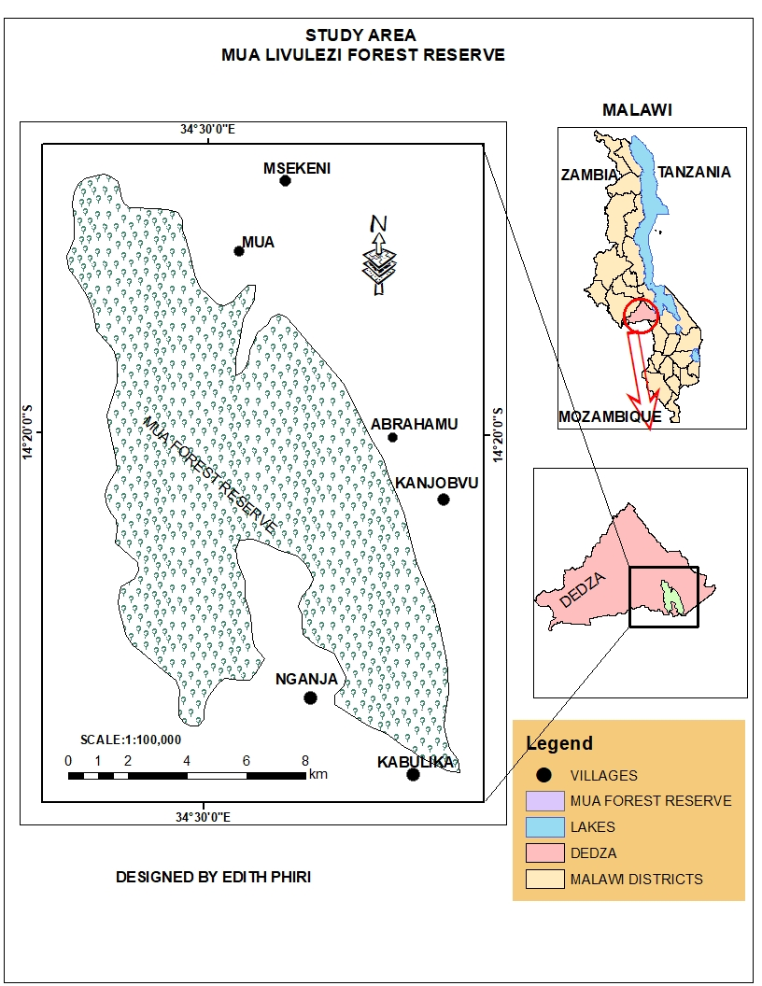

**3.2 RESEARCH APPROACH**

This research will use the mixed approaches of gathering information. A mixed methods research design is a procedure for collecting, analyzing and evaluating the data using both qualitative and quantitative research methods in a single study to understand a research problem (Creswell, 2017). This study intends to use mixed approach which consist of qualitative and quantitative approach. Qualitative approach will be used to know the levels of community participation in forest management and conservation at Mua-Livulezi forest reserve. Quantitative approach will be used to calculate the percentage of community members who are effectively participating in forest management and conservation at Mua-Livulezi forest reserve. The quantitative data will be subjected to Statistical Packaging for Social Science (SPSS) and analyzed using statistical tool named analysis of variance (Anova) to compare the means**.** This study will also intend to use cross-sectional survey design in determining how effective the community is towards forest management and conservation. This is so because it used to assess different people in the population. The study will use both primary and secondary data.

**3.4 SAMPLE SIZE**

Target population will be involve forest management officers, village heads and community participants. Yamane’s formula will be used to calculate the number of people to be sampled. Below is the formula which will be used to calculate sample size.

n= N/ 1+Ne2

Where:

n = sample size

N= population size

e = the error of sampling

**3.5 SAMPLE PROCEDURES**

Sampling is a technique of selecting individual members or a subject of the population to make statistical inferences from them and estimate characteristics of the whole population (Bodnar, 2018). The study will use both probability and non-probability sampling methods. Purposive method will be used under non-probability sampling. Purposive method will be used to collect data from community representatives and forest officers at Mua-Livulezi forest reserve. Stratified random sampling will be used under probability sampling methods. Stratified sampling method will be used to collect data from communities whereby population will be divided into small groups.

**3.5 DATA COLLECTION TECHNIQUES AND TOOLS**

Data will be acquired through interviews, questionnaires and focus group discussions

**3.5.1 Questionnaire**

These will be composed of both closed and open ended questions. This will look at some of the challenges like lack of community involvement in Mua-Livulezi forest management, lack of proper knowledge about the advantages of sustainable forest resource use and also will help answer the research objectives.

**3.5.2 Interviews**

Interview will be conducted to collect information from key respondents like forest officers, Community representatives, Village heads and Community members and interview guide will help the researcher to collect information through interacting and hence gather detailed data.

**3.5.3 Focus group discussion**

Discussions will be held in groups of both men and women, which will help to obtain relevant information on how best forest resources is managed and conserved in Mua-Livulezi forest reserve.

**3.6 DATA ANALYSIS**

Data analysis is the process of systematically applying statistical and or logical techniques to describe and illustrate, condense and recap and evaluate data (Creswell, 2017). This study will use statistical packaging for social sciences (SPSS) to analyze quantitative data. Descriptive statistics will be used to determine frequencies, percentages and the mean. And also chi-square to determine association of variables.

Y=µ1 +µ2 +…µe

µ1 represent benefits accomplished by communities

µ2 represent roles played by communities

µe represent unidentifiable factors

**LIMITATION OF THE STUDY**

The limitation of the study can be due to political environment, this is so because forest officers might be restricted to provide sensitive information for political reasons and this might affect the study. Another limitation is time and weather whereby during data collection period it might happens to have bad weather such as heavy rainfall which may lead to poor results.

**ETHICAL CONSIDERATION**

Ethics in research is a codification of scientific morality in practice. The ethics in research include dignity, confidentiality and anonymity (Morse, 2010). Therefore, it is important to adhere to ethical principles to the participants. The study will take account issues of confidentiality whereby respondents will not be forced to give information which they feel is confidential and their names and pictures will not be reviewed or written in any document without their consent. The study will also look at voluntary participation whereby it will allow all members in the community to participate by giving their views concerning forest conservation. It will also look at the issue of dignity whereby cultural believes of the participants will be respected.

**RESEARCH STRATEGIC PLAN**



**RESEARCH BUDGET**

|  |  |
| --- | --- |
| EXPENSES | ESTIMATED COSTS (Mk) |
| Airtime for communication | 5,000 |
| Transport | 20,000 |
| Meals and refreshments | 20,000 |
| Research Assistance allowance | 20,000 |
| Stationery | 5,000 |
| Accommodation | 20,000 |
| Total Cost | 90,000 |

**REFERENCES**

Bodnar, M., Namiesnik, J., & Konieczka, P. (2018). Validation of a sampling procedure. TRAC Trends in Analytical chemistry, 51, 117-126.

Coulibaly-Lingani, P., Savadogo, P., Tigabu, M., & Oden, P. C. (2017). *Factors influencing people’s participation in the forest management program in Burkina Faso, West Africa*. Forest Policy and Economics, 13(4), 282-302.

Creswell, J.W. (2017). Research design: Qualitative, quantitative and mixed methods approaches. SAGE publications, Inc. Thousand oaks, CA.

De Vente, J., Reed, M. S., Stringer, L. C., Valente, S., & Newing, J. (2016). *How does the context and design of participatory decision making processes affect their outcomes*? Evidence from sustainable land management in global dry lands. Ecology and society, 21(2).

Forest and Agriculture Organization of the United Nations (FAO). (2016). Global forest resources assessment: Main report. FAO, Forestry paper No.163, Rome.

Gashu, K., & Aminu, O. (2019*). Participatory forest management and smallholder farmers’ livelihoods improvement nexus in Northwest Ethiopia*. Journal of sustainable forest, 38(5), 413-426

Kabir, K. H., Knierim, A., Chowdhury, A., & Darr, D. (2021). What Matters for the job performance of field advisors: a case of participatory forest management in madhupur sal forest in Bangladesh. Journal of Sustainable forestry, 1-20.

Keller, D. (2019). Community participation in sustainable forest management; Stichting Tropenhos International: Netherlands.

Kunje, M. B. (2018). An assessment of community based management of forest resources: a Malawi case study.

Kura, D. W., Li, H., & Shang, D (2018). Study on the influential factors of the involvement of local people in participatory forest management: the case of Wof-Washa district, Ethiopia. Chief Editor.

Munthali, M, G., Davis, N., Adeola, A. M., & Botai, J. O. (2020). The impacts of land use and land cover dynamics on natural resources’ and rural livelihoods in Dedza District, Malawi. Geocar International, 1-18.

Njera, D., Masangano, C., Makungwa, S., Kayambazinthu, D, & Missanjo, E. (2017). Effectiveness of Local Institutions in Forest Management. International journal, 23(4), 161-171.

Senganimalunje, T. C., Chirwa, P. W., & Babalola, F. D. (2015). Potential of institutional arrangements for sustainable management of forests under co-management with local forest organizations in Mua-Livulezi Forest Reserve, Mtakataka, Malawi. International Forest Review, 17(3), 340-354.

Siraj, M., Zhang, K., Xiao, W., Bilal, A., Gemechu, S., Geda, K & Xiaodan, L. (2018). Does participatoryu forest management save the remnant forest in Ethiopia? Proceedings of the National Academy of science, India section B: Biological sciences, 88(1), 1-14.

Tacconi, L., Gamage, D. (2017). Sri Lanka Community Forestry Program (SLCFP): Independent Completion Report; Department of Foreign Affairs Trade: Corombo, Sri Lanka.

**Results**

**General average**

|  |
| --- |
| Descripitive statistics on the data Forest |

The MEANS Procedure

| **Analysis Variable : Fconvpa Number of people in forest conservation participation per family** | | | | | | | |
| --- | --- | --- | --- | --- | --- | --- | --- |
| **N** | **Mean** | **Mode** | **Median** | **Std Dev** | **Range** | **Minimum** | **Maximum** |
| 42 | 1.86 | 2.00 | 2.00 | 1.30 | 5.00 | 0.00 | 5.00 |

**Geder comparisons**

|  |
| --- |
| Descripitive statistics on the data Forest |

The MEANS Procedure

Gender of participant=Male

| **Analysis Variable : Fconvpa Number of people in forest conservation participation per family** | | | | | | | |
| --- | --- | --- | --- | --- | --- | --- | --- |
| **N** | **Mean** | **Std Dev** | **Range** | **Mode** | **Median** | **Minimum** | **Maximum** |
| 24 | 2.29 | 1.27 | 5.00 | 2.00 | 2.00 | 0.00 | 5.00 |

Gender of participant=Female

| **Analysis Variable : Fconvpa Number of people in forest conservation participation per family** | | | | | | | |
| --- | --- | --- | --- | --- | --- | --- | --- |
| **N** | **Mean** | **Std Dev** | **Range** | **Mode** | **Median** | **Minimum** | **Maximum** |
| 18 | 1.28 | 1.13 | 4.00 | 1.00 | 1.00 | 0.00 | 4.00 |

|  |
| --- |
| **Research question 1 Benefits** |

The FREQ Procedure

| **What are the benefits obtained** | | | | |
| --- | --- | --- | --- | --- |
| **whatbenefits** | **Frequency** | **Percent** | **Cumulative Frequency** | **Cumulative Percent** |
| **Local medicine** | 4 | 9.52 | 4 | 9.52 |
| **Fuels** | 15 | 35.71 | 19 | 45.24 |
| **Forest foods** | 3 | 7.14 | 22 | 52.38 |
| **Construction materials** | 2 | 4.76 | 24 | 57.14 |
| **Income** | 4 | 9.52 | 28 | 66.67 |
| **forest farming** | 11 | 26.19 | 39 | 92.86 |
| **None** | 3 | 7.14 | 42 | 100.00 |
|  |  |  |  |  |

**General graph**

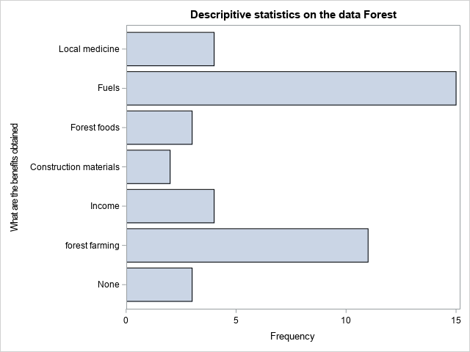

**Gender comparisos**

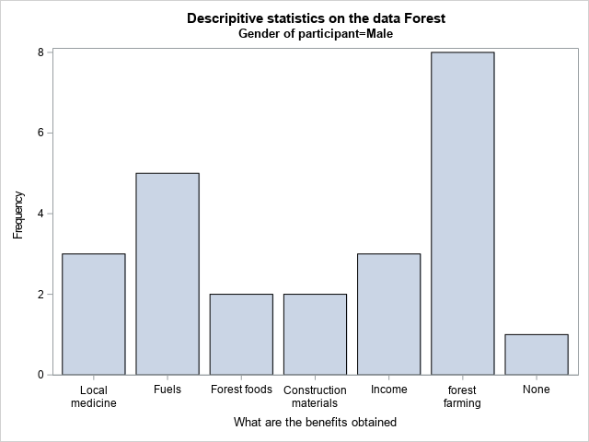

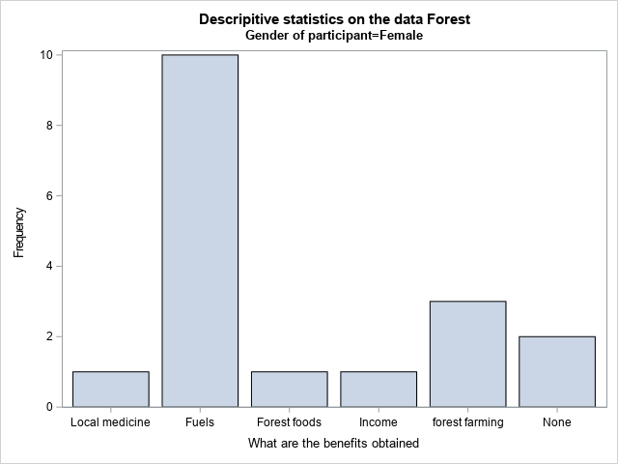

|  |
| --- |
| **Research quest 2 Roles In community participation** |

The FREQ Procedure

| **Your part in conservation** | | | | |
| --- | --- | --- | --- | --- |
| **Your_part_in_conservation** | **Frequency** | **Percent** | **Cumulative Frequency** | **Cumulative Percent** |
| **Afforestation** | 15 | 35.71 | 15 | 35.71 |
| **Maintaining fire breaks** | 12 | 28.57 | 27 | 64.29 |
| **Controlling worton cutting down of trees** | 6 | 14.29 | 33 | 78.57 |
| **None** | 9 | 21.43 | 42 | 100.00 |

**Gender comparisons for community participation**

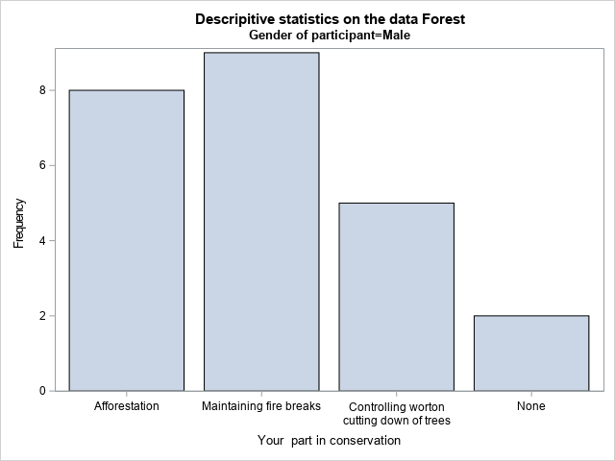

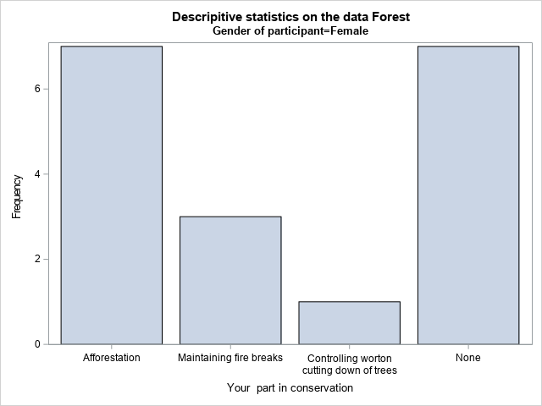

|  |
| --- |
| **Research quest 3 Challenges in conservation** |

The FREQ Procedure

| **What are the challenges faced when conserving the forests** | | | | |
| --- | --- | --- | --- | --- |
| **Challenges** | **Frequency** | **Percent** | **Cumulative Frequency** | **Cumulative Percent** |
| **Discrimination** | 8 | 19.05 | 8 | 19.05 |
| **Lack of coperation** | 7 | 16.67 | 15 | 35.71 |
| **Dangerous animals** | 8 | 19.05 | 23 | 54.76 |
| **Civic education** | 6 | 14.29 | 29 | 69.05 |
| **Negligence** | 3 | 7.14 | 32 | 76.19 |
| **Ambushed** | 2 | 4.76 | 34 | 80.95 |
| **Dont have challeges** | 8 | 19.05 | 42 | 100.00 |

**General Challenges**

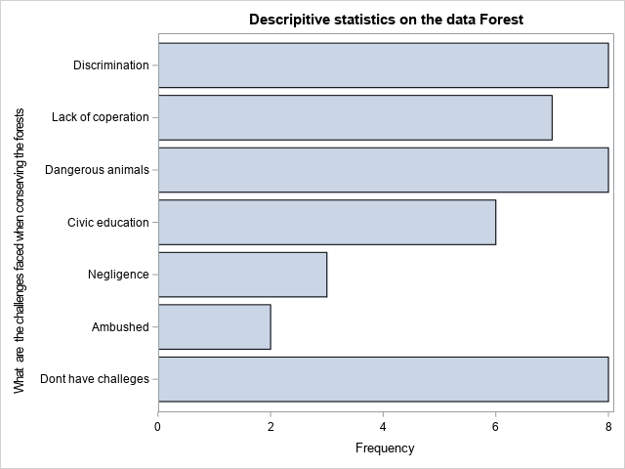

**Gender comparisons on challenges**

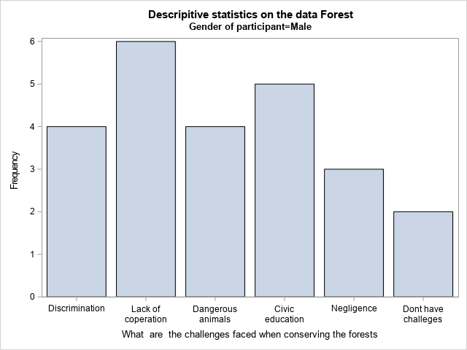

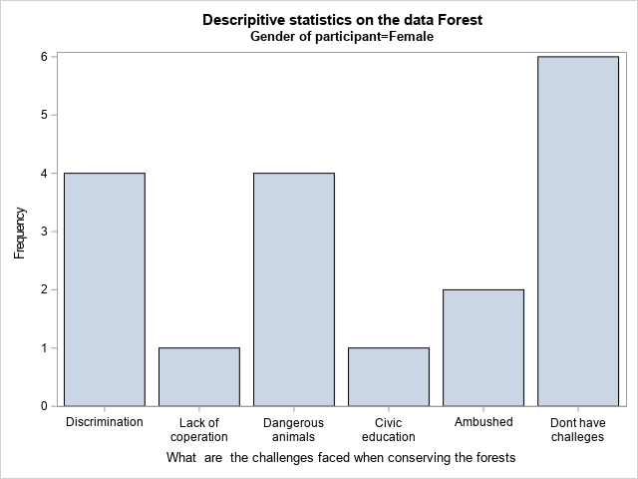

**The End**

**Commands**

**PROC** **IMPORT** OUT= SAS.edith

DATAFILE= "C:\Users\Chikuni's\Documents\SPSS - WORKS\work wo

rk\EDITH PHIRI LIKWEZI.sav"

DBMS=SPSS REPLACE;

**RUN**;

**proc** **print** data=sas.edith;

**run**;

Title'Descripitive statistics on the data Forest';

/*sort the data*/

**Proc** **sort** data=sas.edith;

by gender Level_of_education; **run**;

/*Means procedure*/

Title'Descripitive statistics on the data Forest';

**Proc** **means** data=sas.edith maxdec=**2** n mean mode median std range min max ;

var fconvpa; **run**;

/*participatio y geder*/

**Proc** **means** data=sas.edith maxdec=**2** n mean std range mode median min max ;

var fconvpa;by gender; **run**;

/*first research question */

/* •What are benefits of forest based products and services that support the livelihoods of local communities in

participatory forestry management at Mua-Livulezi forest reserve? */

**proc** **freq** data=sas.edith;

tables whatbenefits;

/*graph*/

**proc** **sgplot** data=sas.edith;

hbar whatbenefits;

**run**;

/*community roles in conservation by gender & Level_of_education */

**proc** **sgplot** data=sas.edith;

vbar whatbenefits;

by gender;

**run**;

/*************************************************************************************************************************/

/*secod research question */

/* •What are the roles played by communities in forest conservation at Mua-Livulezi forest reserve? */

**proc** **freq** data=sas.edith;

tables Your_part_in_conservation;

/*ka graph kake*/

**proc** **sgplot** data=sas.edith;

vbar Your_part_in_conservation;

by gender;

**run**;

/****************************************************************************************************************************/

/*Third research question */

/*• What are the problems encountered during community participation in forest conservation at Mua-Livulezi forest reserve? */

**proc** **freq** data=sas.edith;

tables Challenges;

**run**;

/*ka graph kake*/

**proc** **sgplot** data=sas.edith;

hbar Challenges;

**run**;

**proc** **sgplot** data=sas.edith;

vbar Challenges;

by gender;

**run**;